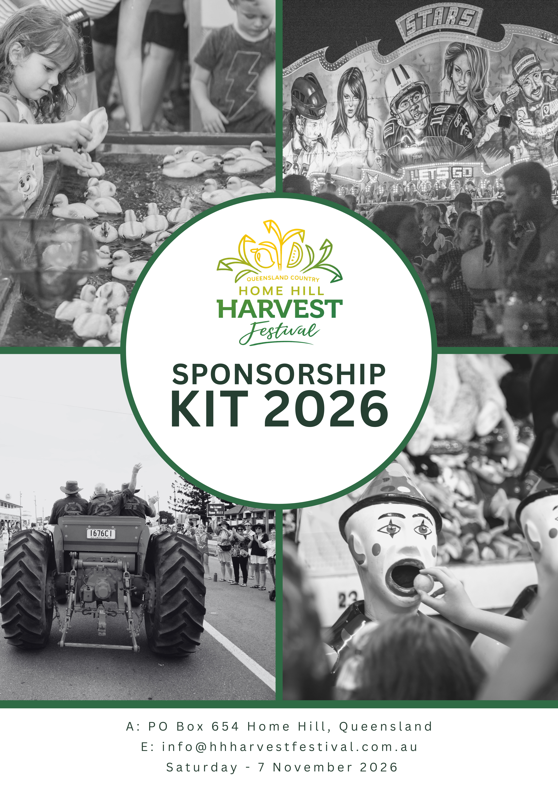

Harvest Festival Sponsorship Opportunities
Thank you for considering sponsorship of the Home Hill Harvest Festival. Your support plays a crucial role in making this community event a success. As a sponsor, you'll gain valuable exposure and demonstrate your commitment to the Burdekin community.
Why Sponsor?
- Community Engagement: The Harvest Festival is deeply ingrained in the local community, attracting a diverse audience of residents, families, and visitors. By sponsoring the event, your organization demonstrates its commitment to supporting community initiatives and engaging with local residents. You can demonstrate your company's dedication to supporting local communities and fostering positive relationships with residents. Your involvement not only strengthens community ties but also showcases your commitment to social responsibility.
- Brand Exposure: As a sponsor, your organisation will benefit from extensive brand exposure before, during, and after the festival. With opportunities for logo placement on promotional materials, event banners, and the festival website, sponsoring the Harvest Festival offers valuable visibility for your brand. Gain extensive brand exposure to a diverse audience of attendees, including local residents, visitors, and participants.
- Targeted Marketing: Sponsoring the Harvest Festival provides unique marketing opportunities to showcase your products or services to a captive audience. From both spaces at the festival to customized marketing initiatives, sponsors can leverage the event to promote their offerings and connect with potential customers. The Harvest Festival offers a unique platform to target your marketing efforts specifically to the Burdekin community and surrounding areas. Connect with potential customers in a relaxed and festive atmosphere, allowing for meaningful interactions and engagement opportunities.
- Networking Opportunities: The Harvest Festival offers sponsors the chance to network with other businesses, community leaders, and festival attendees. By participating in festival activities and events, sponsors can build valuable relationships and foster connections within the community. Forge valuable connections, explore potential collaborations, and expand your professional network while supporting a worthy cause.
- Positive Brand Association: Align your brand with the positive sentiments and community spirit of the Harvest Festival. By supporting this beloved event, you position your company as a caring and involved member of the community, enhancing brand reputation, and fostering goodwill among consumers.
- Long -Term Impact: Your sponsorship not only contributes to the success of the current Harvest Festival but also lays the foundation for future collaborations and partnerships. Establishing a positive presence at community events can lead to ongoing brand loyalty and sustained customer engagement over time. By sponsoring the Harvest Festival, your organization contributes to the success of a beloved community event that celebrates local culture, heritage, and tradition. Your sponsorship helps ensure the festival's continued growth and success for years to come.
- Customized Marketing Opportunities: As a sponsor, you'll have the flexibility to tailor your marketing activities and engagement initiatives to align with your company's objectives and target audience. From branded activations to customized promotions, the Harvest Festival offers a range of opportunities to showcase your brand in a way that resonates with attendees.
- Supporting Local Economy: Investing in community events like the Harvest Festival contributes to the economic vitality of the region by stimulating local businesses, supporting job creation, and driving tourism. Your sponsorship directly contributes to the prosperity and growth of the Home Hill community.
- Enhanced Corporate Image: Sponsoring the Harvest Festival allows your company to enhance its corporate image by showcasing its commitment to supporting cultural events, promoting community well-being, and fostering a sense of belonging. Strengthen brand authenticity and trust by actively participating in meaningful community initiatives.

Sponsorship Levels:
Sponsorship Level | Investment | Benefits
Naming Rights Sponsor | $8000 | Exclusive naming rights to the Home Hill Harvest Festival  Prominent logo placement on all promotional materials  Event banners placed at every event (Supplied by sponsor)  Prominent listing on the festival website with a clickable link, as well as in the printed program and coffee table book  Recognition in press releases , radio, and media coverage  Customised marketing opportunities  Customised Social Media Shout -outs and mentions  Complimentary booth space at the festival  Drink Tickets - to be collected Harvest Festival Street Party  8 Complimentary Tickets to the Harvest Festival Ball  A coffee table book for prominent display in your reception or office area  Opportunity to distribute marketing materials at events  If sponsoring a Harvest Festival Queen, the queen fee is included in the sponsorship package
Platinum Sponsor | $5000 | Logo placement on all promotional materials  Event banners placed at every event listing on the festival website with a clickable link, as well as in the printed program and coffee table book  Recognition in press releases, radio, and media coverage  Customised marketing opportunities  Customised Social media shout -outs and mentions  Drink Tickets – To be collected at the Harvest Festival Street Party  6 Complimentary Tickets to the Harvest Festival Ball  A coffee table book for prominent display in your reception or office area  If sponsoring a Harvest Festival Queen, the queen fee is included in the sponsorship package
Gold Sponsor | $3000 | Recognition in press releases, radio, and media coverage  Customised Social media shout-outs and mentions  Listing on the festival website with a clickable link, as well as in the coffee table book  A coffee table book for prominent display in your reception or office area  Drink Tickets – to be collected at the Harvest Festival Street Party  If sponsoring a Harvest Festival Queen, the queen fee is included in the sponsorship package
Silver Sponsor | $1500 | Verbal acknowledgment during festival announcements  Opportunity to provide branded merchandise or samples  Social Media Shout -outs and mentions  Listing on the festival website and any advertising for the event you are sponsoring  If sponsoring a Harvest Festival Queen, the queen fee is included in the sponsorship package
Bronze Sponsor | $750 | Social Media Shout-outs and mentions Listing on the festival website and any advertising for the event you are sponsoring Listing on the festival website with a clickable link, as well as in the coffee table book
In Kind Sponsor | Varies | Recognition equivalent to the corresponding sponsorship level Customized benefits based on the value of the in-kind contribution Social Media Shout-outs
Breakdown of 2023 Radio Stats:
Triple M reaches from Cardwell to Bowen, with 69,500 people tuning in each week.
We received 246 x 30 second commercials in total, all placed between 6am and 8pm, valued at $14,760.
Home Hill Harvest Festival Program
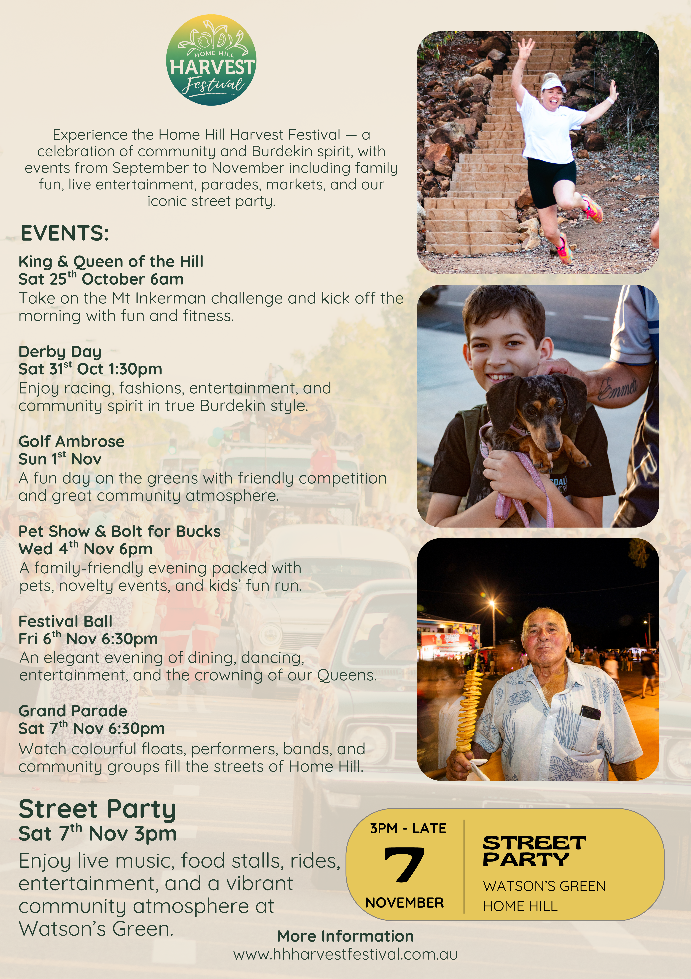
Sponsoring the Harvest Festival represents more than just a marketing opportunity; it's a chance to deeply
embed your brand within the fabric of the Burdekin community while strategically advancing your business
objectives. As a sponsor, you'll enjoy extensive brand exposure across various platforms, including digital
and print media, ensuring your message reaches a wide audience. This exposure is complemented by
tailored marketing opportunities designed to resonate with your target demographic, offering a unique
avenue to connect with potential customers.
Moreover, sponsoring the Harvest Festival provides invaluable networking opportunities, allowing you to
forge connections with other local businesses, community leaders, and festival attendees. These
connections can lead to mutually beneficial partnerships, collaborations, and business opportunities that
extend beyond the duration of the event.
Beyond the tangible benefits, sponsoring the Harvest Festival demonstrates your company's commitment
to community engagement and corporate social responsibility. By supporting this cherished event, you
align your brand with values of inclusivity, celebration, and community spirit, enhancing your reputation
and fostering goodwill among local residents.
In essence, sponsoring the Harvest Festival is more than a business transaction; it's an investment in the
vibrancy and vitality of the Burdekin community. It's an opportunity to leave a lasting legacy of support and
involvement, creating meaningful experiences for festivalgoers and contributing to the cultural richness of
the region. We invite you to join us in celebrating the Harvest Festival and becoming an integral part of this
cherished community tradition.
Contact Information: For more information or to discuss sponsorship opportunities, please contact:
Debbie Simpson – Sponsorship Coordinator – 0422 637 326 or email us at info@hhharvestfestival.com.au

