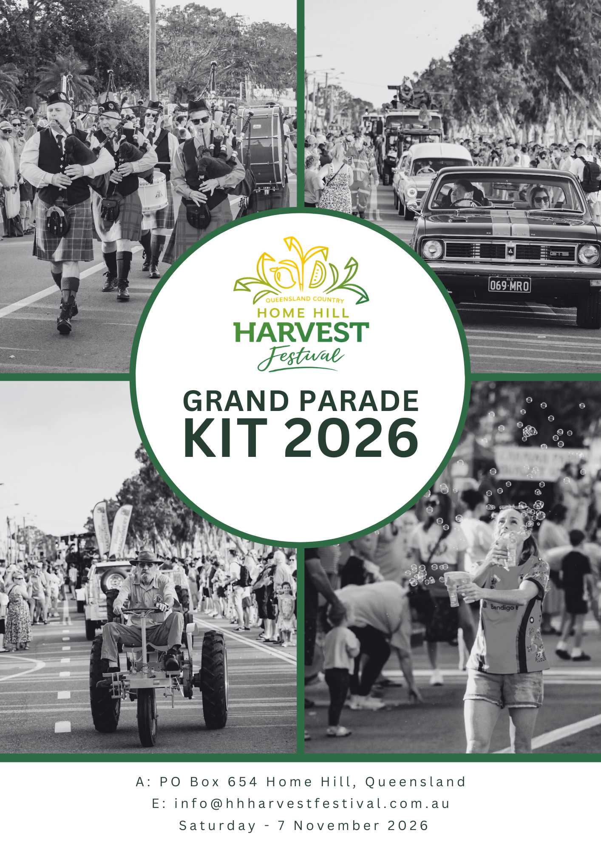

General Rules for Grand Parade Floats
HOW TO ENTER:
- Entry is free, and forms are available from either the festival website www.hhharvestfestival.com.au or by emailing us at info@hhharvestfestival.com.au
- The Application Form must be received no later than 5 pm on Friday, 7th November 2025.
- The theme of the Grand Parade is “Our Town!” All persons accompanying the float, either riding or on foot, should wear costumes or clothing in keeping with the theme of that Float. We also ask that all participants in the Parade make a reasonable effort to decorate their entry to align with the “Our Town!” theme. Have fun and use your imagination!

CONDITIONS OF ENTRY:
- The Home Hill Harvest Festival Committee will not be financially liable to any participants, except for prize monies awarded.
- ALL vehicles must be roadworthy, registered, and insured as a condition of participation in the Grand Parade.
- The Festival Committee and its Officers, while prioritising safety, do not accept any responsibility/liability for damage to property or the general public along the Parade route.
- The Festival Committee reserves the right to decline any entry not considered appropriate or not in compliance with the conditions set out in the Information Pack.
- Due to safety concerns, please ensure that all lollies thrown from the float land away from the vehicle route to prevent children from running between floats and close to vehicle tires.
- Each float must have at least one volunteer walking in front to keep the road clear and ensure the safety of parade participants and spectators.
- Floats are judged in all categories – if you do not wish to be judged, please indicate this on your application form.
- NO ALCOHOL may be consumed by any persons in the Parade marshalling area or on any float at any time during the parade.

FLOAT IDENTIFICATION & PARADE POSITION:
The Parade Marshall and their assistants will assign positions on the day. All participants must be ready at the appointed time. If you are not ready when called, you will be placed at the end of the parade, and no effort will be made to slot you into your original category.

PARADE MARSHALLING & TIMES:
The Parade Marshall or Marshall’s assistant/s are to be consulted on all matters concerning your entry into the Grand Parade. If you have questions, please ask, and these people will assist.
On Saturday, 7th November 2026:
3:00 pm: Floats will meet in front of Ashworth’s Jewellery and along 14th Street. Floats will be positioned in the order the Parade Marshall puts you in, and drivers must remain with their float after arrival.
4:30 pm: Floats are to be assembled and in their correct positions.
5:00 pm: The float procession will begin.
PARADE ROUTE:
The Parade route will run along Eighth Avenue until the junction of Eighth Street, where the lead float will make a U-turn, travel back along Eighth Ave, and then turn right onto Eleventh St.

DISTANCES TO BE MAINTAINED DURING THE PARADE:
  - During the Parade, drivers of floats are required to maintain a distance of 10 meters between floats, bands, and other groups. The maximum speed permitted is 10 km per hour. If the Parade is stopped, this gap should close to a distance of 5 meters. When the Parade starts up again, the gap is to be increased to 10 meters as before.
  - DO NOT STOP AT ANY TIME unless the float ahead stops, or you are instructed to stop by the Parade Marshall or assistants. In the event of a breakdown, please inform the Parade Marshall immediately, and help will be provided.

FLOAT SPECIFICATIONS:
- The driver’s vision should not be obscured, and adequate provision for visibility must be considered in the float design.
- The exhaust system of motorized floats must extend beyond the apron of the float and have a leak-proof exhaust pipe.
- Illicit material or dangerous items are not permitted in the Parade.
- The Festival Committee has the right to refuse participation.
- If livestock has been granted permission to participate, it is your responsibility to clean up any waste products from livestock.
- When planning your float, consider changes in the streetscape.
- For more information, contact us at info@hhharvestfestival.com.au or visit www.hhharvestfestival.com.au.

Proudly Sponsored by:

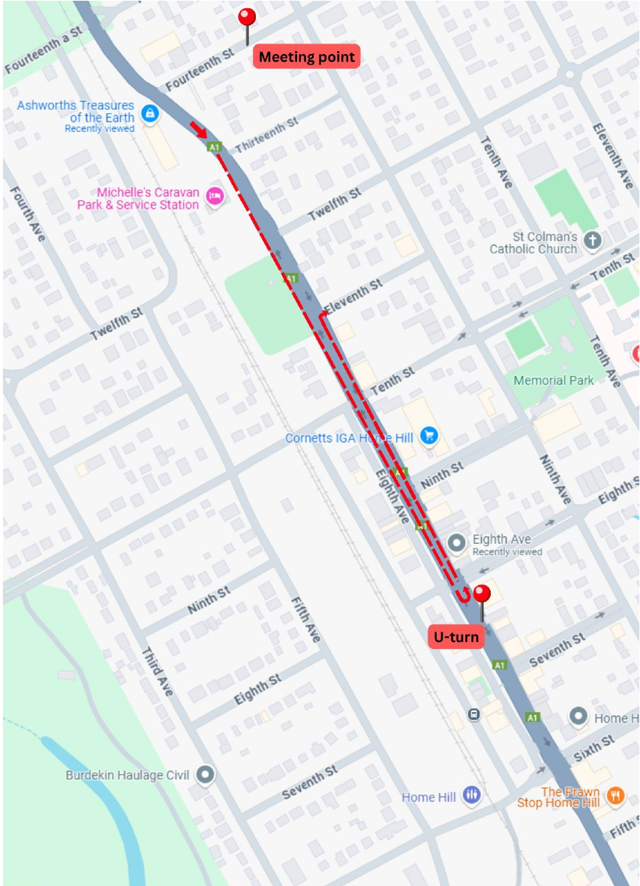
Theme 2026:
Rio Carnivale
Queensland Country Bank
Home Hill Harvest Festival
The “Rio Carnivale” Theme Grand Parade Entry Form
For any assistance, please contact the Home Hill Harvest Festival Committee
info@hhharvestfestival.com.au
( ) Best Queen Float
( ) Best Float, other than a queen
( ) Best Trade Float
( ) Best Humorous Float
( ) Best Bicycle | Individual
( ) Best Theme Float
Note: All entries must carry a copy of their certificate of currency for public liability on the day and please also email back with this form. Floats must be assembled by 4:30pm to allow the Parade coordinator to arrange the parade order. Lollies and other objects must not be thrown from the vehicle. Floats must be assembled at the form of Ashworth’s at 3:00pm.
Organisation Details
NAME: ______________________________________________________________
Address: ____________________________________________________________
Contact Name: _______________________________________________________
Contact Number: _____________________________________________________

Acknowledgment: We the undersigned agree to abide by the rules and regulations as set down by the Home Hill Harvest Festival Committee INC.
Signed: ____________________________________ Date: __________________

